Boca Stewardship Agreement – Implementation Contractor, Bid Sheet
Pricing Schedule
Bidders shall price work according to the schedule below. If Bidders believe that an alternative method of pricing is more applicable, they may also provide an alternative pricing schedule in addition to the format requested below. TRWC, in its sole discretion, reserves the right to utilize any alternative pricing schedule proposed by any Bidders.

All quantities and measurements identified in this RFP are based upon the best knowledge available to TRWC and USFS-TNF and are subject to change. Payment will only be made for actual work completed.

1. Conifer Removal
The selected Contractor agrees to purchase timber removed from the project. The selected Contractor agrees to pay TRWC the following timber rates for product removed:

Cutting Unit Number | Approx Acres | Species | Product | Quantity | Unit of Measure | Rate of Payment $/UOM
All | 1333.86 | CS | Sawtimber | 52,758.90 | TON
200  230  240  270  280  21  290  300 | 532.36 | CS | Sawtimber | Un-Estimated | TON

For timber removal specifications please see Appendix F. Designated haul routes are mapped in Appendix C. Minimum rates for sawtimber are $0.10/TON.

2. Service Work Items

Descriptions for calculations:
Cost Per Unit: The amount it will cost the selected contractor to implement and complete each unit of work for a given work item. This includes all costs associated with a completed unit i.e. labor, profit, etc.

Work Item Cost: The amount it will cost the selected contractor to implement and complete the entire work item. This is calculated by multiplying the #of units' by 'cost per unit'.

Item Number | Item Description | Unit | # of Units | Cost Per Unit | Work Item Cost (# units*cost per unit)
Example | Example | Acres | 100 | $500 | $50,000
1 | Cut, Skid, Deck,  Conifers <  29.9” DBH | Acre | 1,334
2 | Haul Costs (see USFS Appraisal Summary below) | CCF (100 Cubic Feet)
2 | Mastication | Acre | 1,547
3 | Trail Reconstruction | Miles | 4.03
4 | Fireline Reconstruction | Miles | 3.51

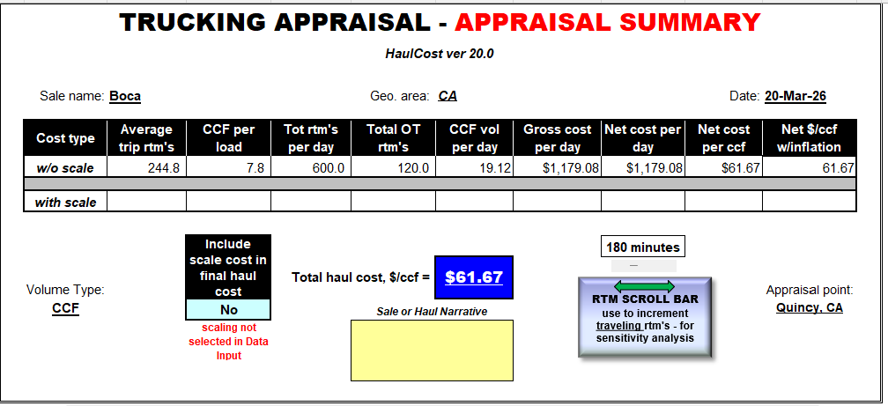

3. Road Maintenance

Applicable to all phases of project implementation (Pre-haul, During Haul, Post Haul)
Road Segment | Approximate Distance (Miles) | Segment Price
787-04 | 1.19
787-04-05 | 0.51
787-04-10 | 0.12
787-04-20 | 0.39
787-10 (Seg-1) | 0.64
787-10 (Seg-2) | 0.28
787-10 (Seg-3) | 0.20
787-10-20 | 0.69
889-33 | 0.63
890-06 | 0.74
890-10 | 0.72
890-10-10 | 0.96
890-10-10-10 | 0.48
890-14 | 1.8
890-16 | 0.96
890-16-02 | 0.08
TOTAL COST

For road maintenance specifications please see the roads package included in Appendix E.

4. Road Reconstruction: All Units.

A road reconstruction plan will be provided by USFS to the selected contractor prior to project implementation. Contractor is responsible for following all aspects of the reconstruction plan, including construction and maintenance of roads, bridges, and other transportation facilities, as needed for conducting treatments on National Forest and other lands where Forest Service has such authority. As used in this supplement Project Agreement, “construct” includes “reconstruct.” See Boca S.A. Road Reconstruction Plans for specific requirements.

Specified Roads.
Name and Date of Governing Road Specifications:
Project |  |  | Design  Class | Approx.  Length  (mi./km.) |  | Sheet Numbers  and  Approval Date | Performance Responsibility
 |  |  |  |  |  |  | Survey | Design | Const.  Staking
Road No. |  | Name
All

